CS340 Client/Server Development
By Nicholas Deniz

CS340 Project Two README
About the Project:
Project Two is a dashboard made for Grazioso Salvare. Its purpose is to let the client interact with the animal shelter dataset that is in MongoDB. Letting the user search for dogs that would be useful for search and rescue training. The dashboard has a unique identifier, the given image that is also a clickable link, interactive filtering options, a data table, a geolocation map, and another chart with corresponds with the filtering of data. This README will show its functionality, show the tools used, provide instructions to recreate it, and show issues that have cropped up.
Functionality:
The dashboard meets the specifications shown in the project PDF. The dashboard has the Grazioso Salvare Logo with clickable link to SNHU, unique identifier with Nicholas Deniz, interactive filters for Water Rescue, Mountain or Wilderness Rescue, Disaster or Individual Tracking, and Reset. The data table responds to that filtering and shows a geolocation chart and a pie graph of the dogs from the dataset. The database queries for the filters meet the rescue table from the specifications PDF. The filters use the required types, breeds, sex, and age ranges for each rescue filter.
Proof of Functionality Screenshots:
Base Dashboard and Reset:
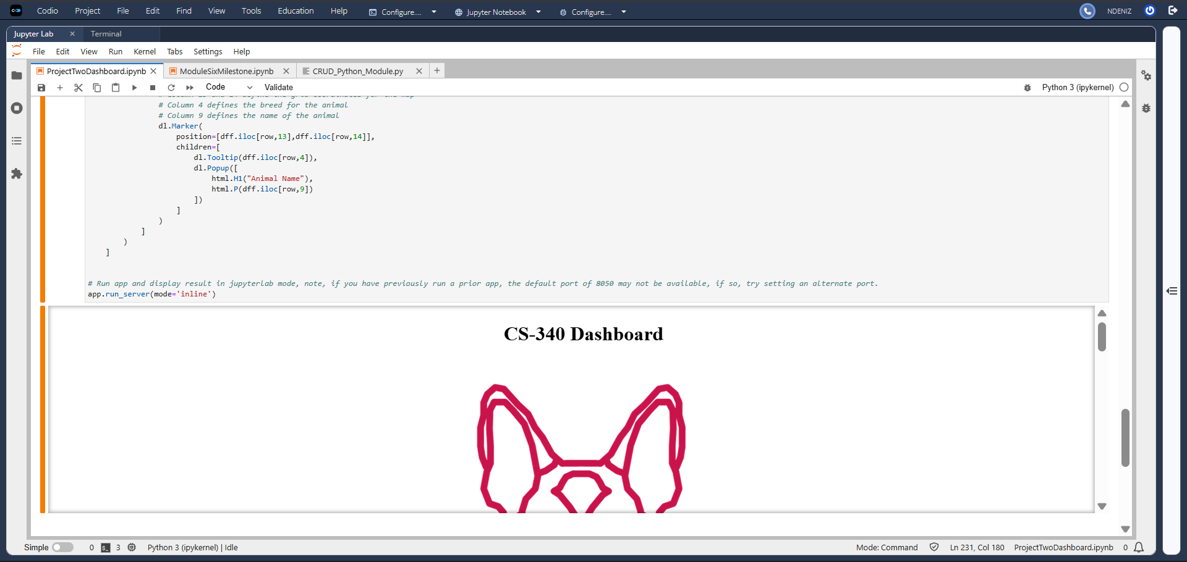
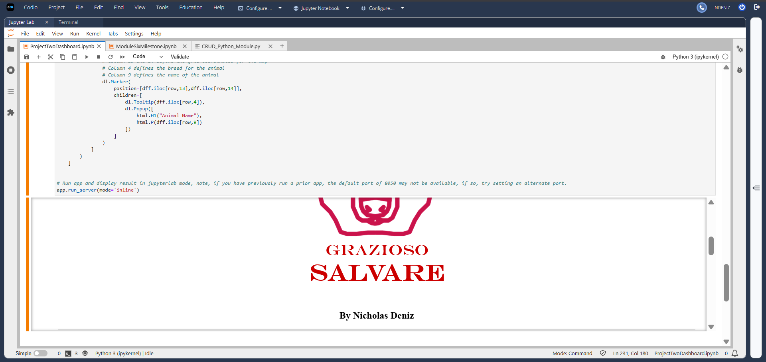
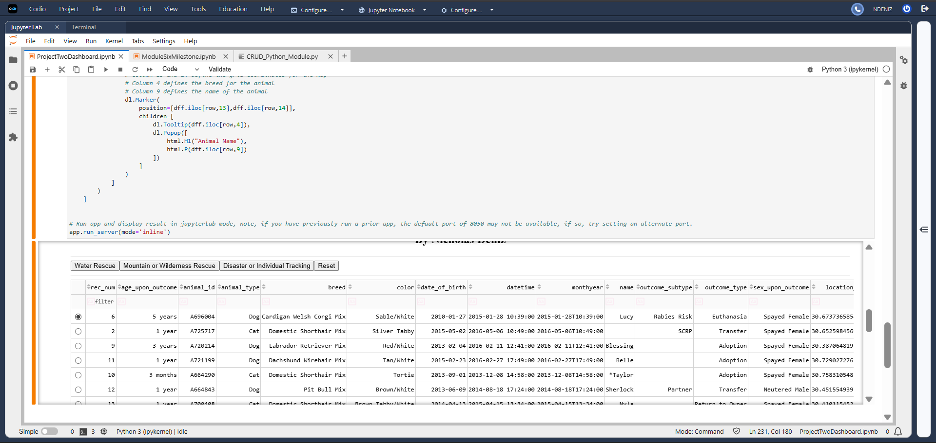
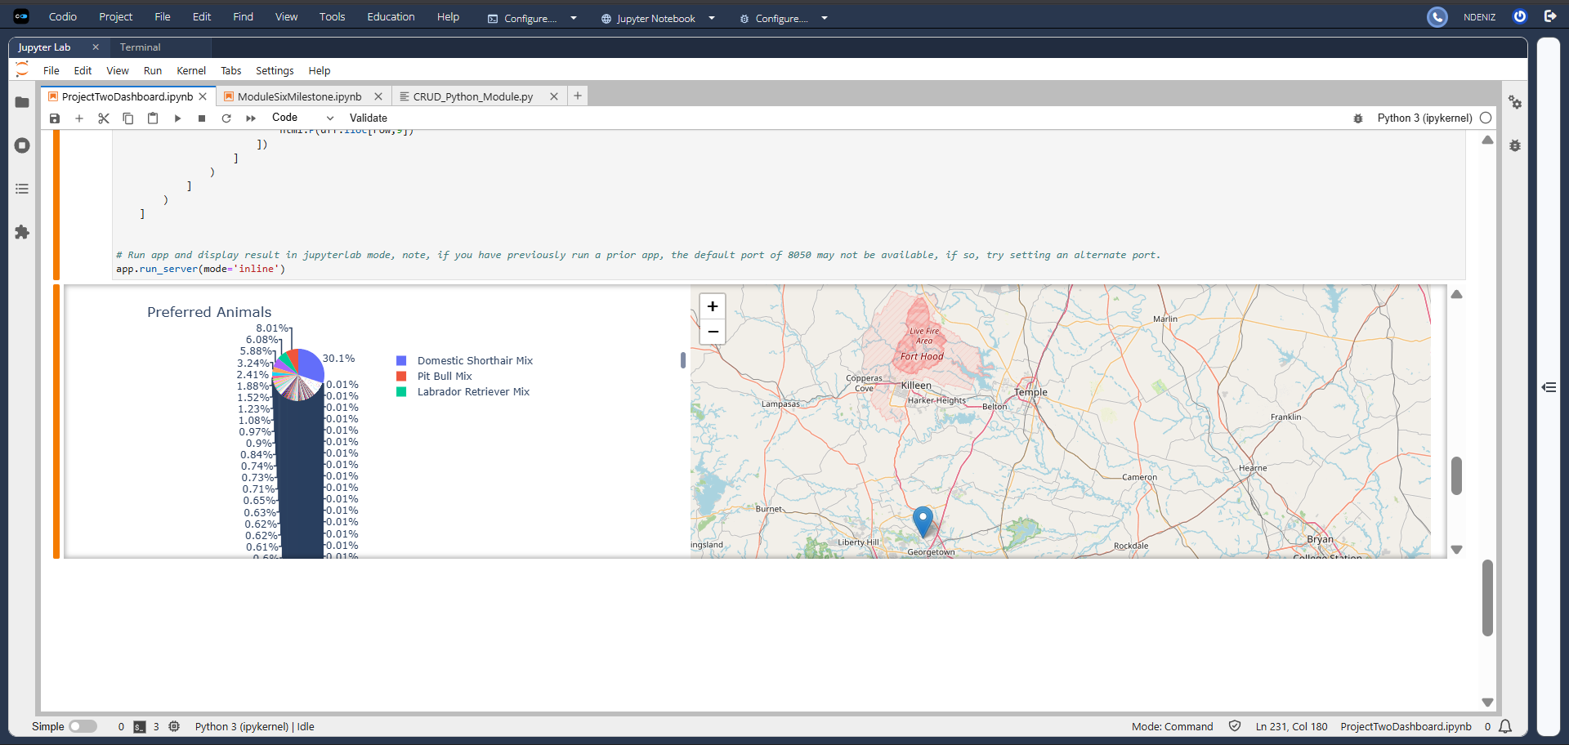
Mountain or Wilderness Rescue:
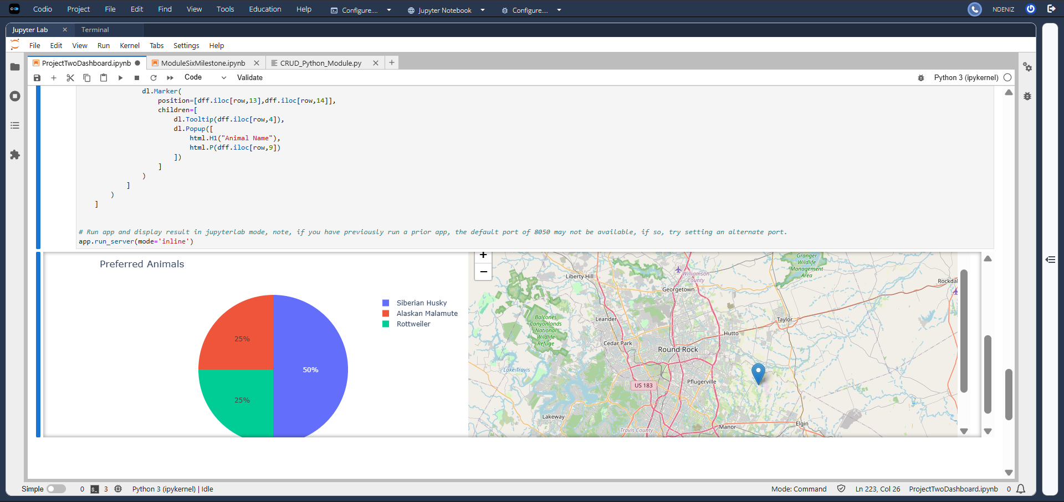
Water Rescue:
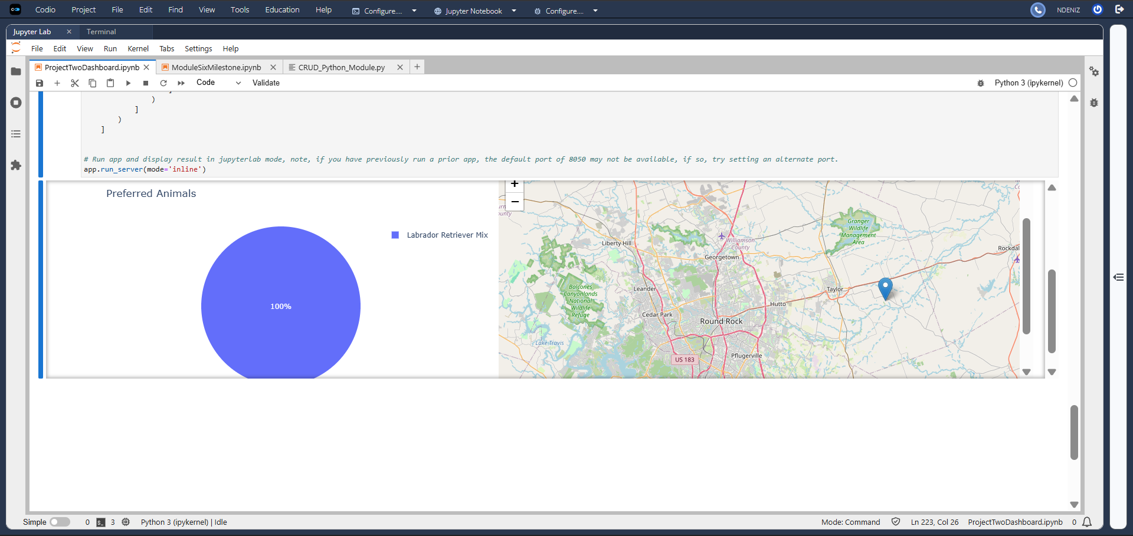
Disaster Rescue:
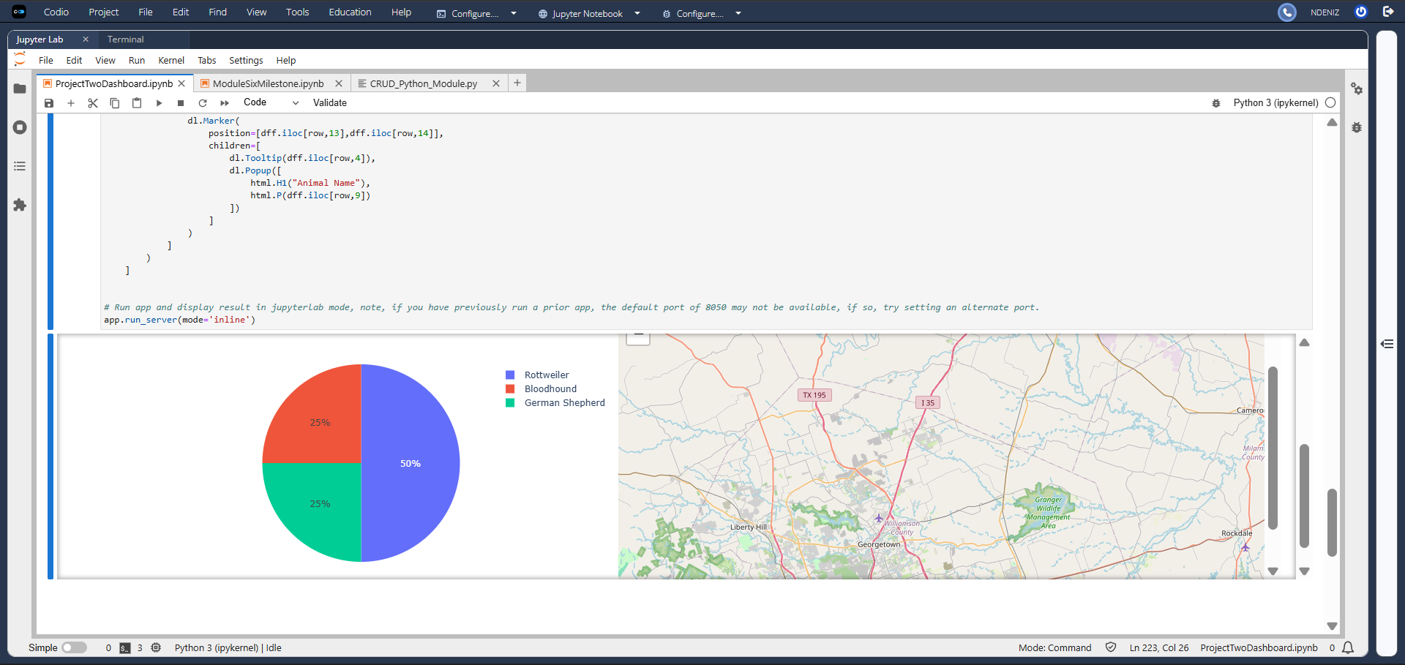
Tools Used:
1. Python was the programming language used and the “glue” holding many of the tools together. Python allowed the dashboard logic, MongoDB queries, and the UI components to be used together.
2. MongoDB was used as the main database, storing the animal shelter dataset that used. My CRUD Python Module has create, read, update, and delete methods which allowed the dashboard to get filtered data from the animal shelter collection.
3. The Dash framework was used because it created structure, the layouts, tables, charts, and the callbacks. Dash was used to connect the interactive options and return data from the callbacks to the Data Table with df.to_dict(‘records’).
4. Pandas was used to take MongoDB query results and put them in data frames. So that data could then be displayed in the Dash Data Table and shown in the charts.
5. Plotly Express was used to create the pie chart, which provides a simple way to show the data being filtered.
6. Dash Leaflet was used to have the geolocation map and display the locations.
7. Jupyter Notebook and Jupyter Dash was used as place to develop the code and then run the dashboard in Codio.
Why was MongoDB used?:
MongoDB was used because the project needed animal shelter data that existed in the MongoDB collection. CRUD Python Module was required to aid in the interaction of that data. MongoDB works great with Python because of the easy way it handles the query results and then turn into a Pandas data frame. Making it possible to apply the rescue filters then updating the dashboard with those results.
Why was Dash used?:
Dash was used because it gives structure and control for the dashboard. The layout creates what is visible like the title, buttons, chart, and data table. The callback functions are the controller, taking inut from the buttons and table then updating what is being output. Dash can connect components through inputs and output IDs which helps when a user chooses their filter.
Steps to complete the project:
- I went through Project Two directions and rubric, the dashboard specifications, and the walkthrough to understand the dashboard structure, filtering, and how the logo and unique identifier need to be.
- I used the CRUD Python Module from Project One so that the dashboard can use it to go through MongoDB animal shelter collection. The CRUD module has create, read, update, and delete methods.
- I connected the dashboard and MongoDB by importing the CRUD module and imprting data into the Pandas data frame.
- I built the dashboard layout with Dash. Including the title, Grazioso Salvare logo, unique identifier, filter buttons, the data table, the pie chart, and the map.
- I wrote the callback functions for each rescue filter, so that they can run a MongoDB query and get the filtered results. I connected the pie chart and geolocation map so they can use that current data to update. The walkthrough shows the general idea for connecting the interactive controls to the output.
- I followed the rescue table specifications that match breeds, sex, and age range for each rescue filter.
- I then tested the dashboard and debugged issues that cropped up. I tested the filtering and map/pie chart display. Taking screenshots as I went through the process.
Challenges and how they were Overcome:
One challenge was making sure the dashboard filters matched the specifications. Making sure to include what was needed for the query like breeds, sex, and age rang. The quiz was a big help in getting a solid idea of what I needed to set up.
Another challenge was getting goods visuals of the layout on Jupyter Notebook. I did the best I could to make it bigger, like showing the map and pie chart equally, but it was difficult to see it through the output cell. I didn’t see anywhere to increase its size.
Another challenge was MongoDB returns a _id field that causes issues for Dash. I fixed this by dropping the _id column before returning the records to the table.
Another challenge was the Reset behavior; I had to make sure that Reset option returned the filtered display data back to its initial state. It was stuck on filtered data, and it was slow or unable to respond properly. I corrected the logic so the reset option would return the original data that hasn’t been filtered.
Resources:
Walkthrough:
https://learn.snhu.edu/content/enforced/2200297-CS-340-18596.202616-1/course_documents/CS%20340%20Module%20Six%20Dashboard%20Sample%20Walkthrough.pdf?isCourseFile=true&ou=2200297
Dash Components:
https://dash.plotly.com/dash-core-components
Dash DataTable:
https://dash.plotly.com/datatable
Dash Leaflet:
https://dash-leaflet-docs.onrender.com/
Pie Chart Plotly:
https://plotly.com/python/pie-charts/
MongoDB:
https://research.ebsco.com/c/ix3dnl/ebook-viewer/epub/6rs46l7ncj/section/navPoint-83
Dashboard Specificatins:
https://learn.snhu.edu/content/enforced/1891737-MASTER-CS-340-GC-M01.202551-1/course_documents/CS%20340%20Dashboard%20Specifications%20Document.pdf?_&d2lSessionVal=ScQoRYLN9OTGv4T9RbCyYwie6&ou=1332057&ou=1891737&ou=2200297
The dataset:
https://learn.snhu.edu/content/enforced/1891737-MASTER-CS-340-GC-M01.202551-1/course_documents/aac_shelter_outcomes.csv?_&d2lSessionVal=ScQoRYLN9OTGv4T9RbCyYwie6&ou=1332057&ou=1891737&ou=2200297
Python:
https://go.oreilly.com/SNHU/library/view/head-first-python/9781491919521/
README Toturial:
https://www.makeareadme.com/
Reproduction of Project Two:
Open Codio and make sure that MongoDB is connected. Insert the CRUD Python Module, the ProjectTwoDashboard, and the logo file. Update the username and password for MongoDB environment. Make sure that the imports, database, data frame, dashboard layout, and callbacks are all loaded in. Open the dashboard and test each filter button to make sure no problems occur by checking the data table, pie chart, and map correspond. Take the screen shots for each rescue filter and reset.

